The Tribe Of Gad In The Bible
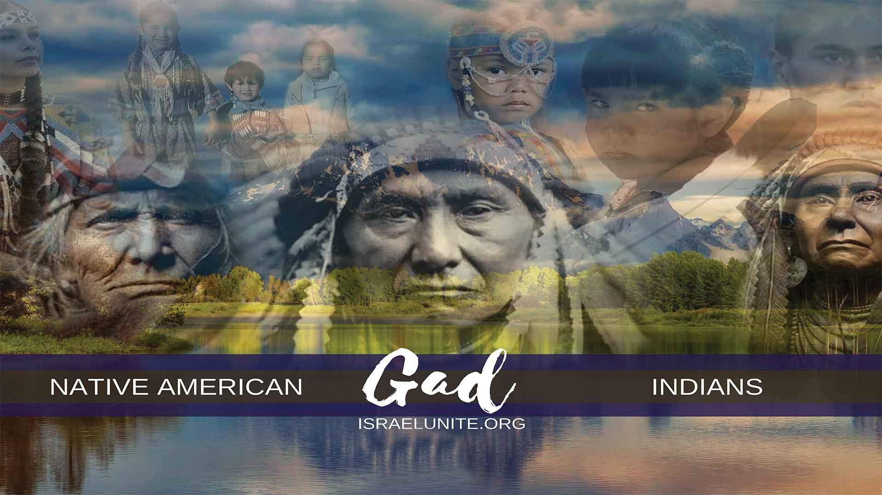
GAD, was the seventh born son of Jacob. His name means “troop”. The word Indian comes from the Latin word “Indio”, meaning slave. They migrated to the Americas, around 536 B.C. during the Persian captivity.
Genesis 49: 1 “And Jacob called unto his sons, and said, Gather yourselves together, that I may tell you that which shall befall you in the last days.” The last days occur from the days of Christ till today.
Genesis 49:19, “Gad, a troop shall overcome him:…”, the “troop” that overcame the tribe of Gad, was the United States Cavalry. This war began with the landing on Plymouth Rock in 1620, and ended at the Battle of Wounded Knee in 1890. Within these 200 years the so-called white man has murdered well over 77 million Indians. They murdered countless men, women and children to occupy stolen lands and establish Church and State. “But he shall overcome at the last.”, the tribe of Gad, shall overcome America, and all the nations with the second coming of the Nation Of Israel’s Messiah; Jesus Christ .
Revelation 2:26, “And he, (of the Israelites), that overcometh, and keepeth my works (Commandments) unto the end (2nd coming of Christ) to him will I give power over the nations.”
Revelation 2:27, “And he shall rule them with a rod of iron; as the vessels of a potter shall they be broken to shivers: even as I received of my Father.”
Deuteronomy 33:1, “And this is the blessing wherewith Moses the man of God blessing the children of Israel before his death.”
Deuteronomy 33:20, “And of Gad, he said, Blessed be he that enlargeth Gad:”, the Most High God enlarged the tribe of Gad, with many sons and daughters, despite the genocide the U.S. Cavalry committed against them. There are over 300 so-called Indian nations that make up the tribe of Gad. “He dwelleth as lion,..”, meaning they dwelled upon the land like predators and their nature is like a “lion”, very fearsome. “And teareth the arm..”, the North American Indians, have become well known for the custom of making a blood brother pact, by cutting their “arms”. “With the crown of the head.”, represents the crown of feathers the Indians wore. The custom of the blood brother pact, was generally done with one who wore the unusual crown of feathers (the war bonnet) to be accepted into the tribe.
“And he provided the first part for himself,” the tribe of Gad, took the best part of the Americas for himself. North America, is the third largest continent in the world. This is the part that Christopher Columbus, was searching for and called it, “the main land”. “Because there, in a portion of the lawgiver, was he seated;”, the tribe of Gad, acted as the priests (lawgivers) during the Migration to the Americas. “And he came with the heads of the people, he executed the justice of the LORD, and his judgments with Israel.”, during the migration, the heads of the people was the tribe of Ephraim and Manesseh, read Deuteronomy 33:17. Gad executed justice and judgement amongst the 10 tribes of Israel, that migrated to the Americas.
1 Chronicles 12:8, “And of the Gadites there separated unto David into the hold to the wilderness men of might, and men of war fit for the battle, the could handle shield and buckler, whose faces were like the faces of lions,…”, the North American Indians, had fearsome faces like lions because they wore war paint every time they went out to battle. “And were as swift as the roes (deers) upon the mountains;…”, the North American Indians, were noted for being swift and elusive runners, to the point that the U.S. Cavalry tricked other Israelites (Apaches/Buffalo Soldiers, etc.) to aid them in capturing many Indian nations, along with the creation of the lethal Gatling Gun which rendered the bows and arrows of the Indians practically useless.
1 Chronicles 5:18, “The sons of Reuben, and the Gadites, and half the tribe of Manasseh, of valiant men, men able to bear buckler and sword, and to shoot with bow, and were skillful in war….”
Bibliography
“Stolen Continents” by Ronald Wright page 235
“It appeared that his hands and feet were torn by iron nails… Then said the man, they slew me… So I have gone home to shut the doors of heaven that they may not see me again until the earth passes away…”
“Now it is rumored that you (Handsome Lake) are but a talker with spirits… Now it is true that I am spirit… of him who was murdered. Now tell your people that they will become lost when they follow the ways of the white man.”
So Christ himself warn against Christianity . SHALOM

